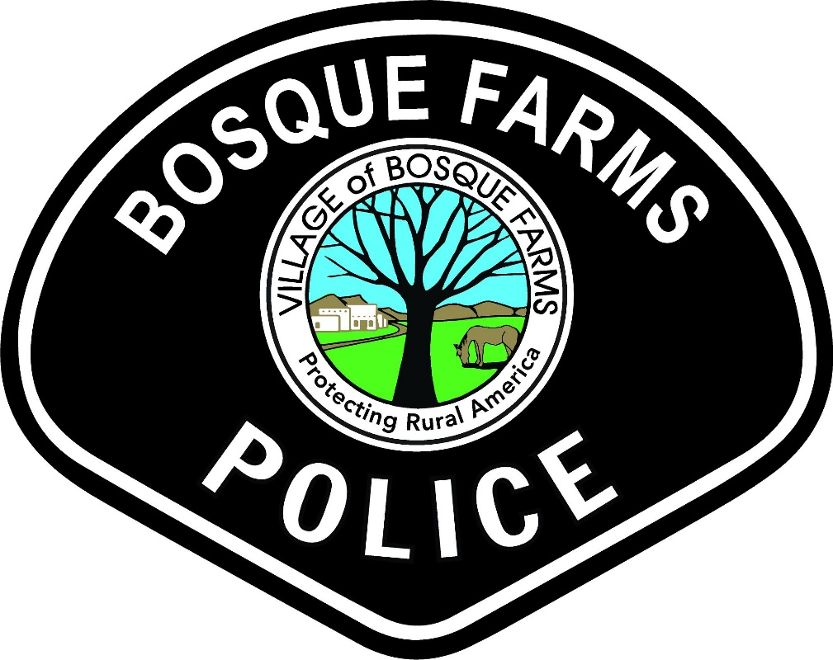
BOSQUE FARMS POLICE DEPARTMENT

OBSERVATION PERIOD:
APRIL 1-30, 2026
PRESENTED BY: INTERIM CHIEF ADAMS
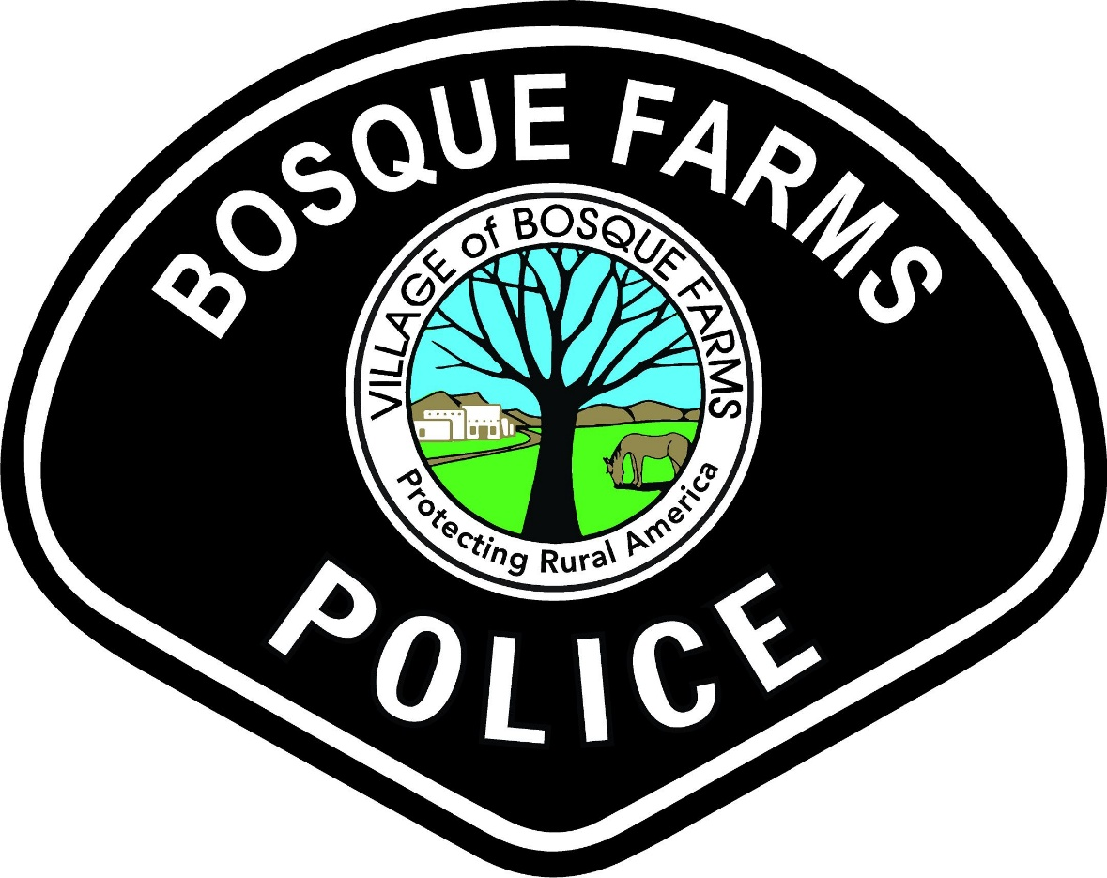
MONTHLY PATROL STATISTICS BREAKDOWN
CALLS FOR SERVICE TRAFFIC STOPS CITATIONS
BOSQUE FARMS: 238 BOSQUE FARMS: 61 BOSQUE FARMS: 19
PERALTA: 151 PERALTA: 127 PERALTA: 76
TOTAL: 389 TOTAL: 188 TOTAL: 119

ARRESTS DWI ARRESTS REPORTS
BOSQUE FARMS: 0 BOSQUE FARMS: 0 BOSQUE FARMS: 30
PERALTA: 3 PERALTA: 0 PERALTA: 16
TOTAL: 3 TOTAL: 0 TOTAL: 46
Significant Event:
-AC1/L1- Attended Animal Care Expo 2026
-111/117- Attended STEP Training
-S2- Attending Staff and Command Training
-112/116- Attending Supervisor Police Personnel Training
-L1- Assisted NMLEA with DWI Instruction
-Completed onboarding with AXON for body and dash cameras and upfitting for entire police fleet
-Officers worked NMDOT Traffic Grant Operations
-State grant approved for Police/Animal Control fleet upgrades
-Attended Peralta Council Meeting
-Attended Metro Public Safety Day Event

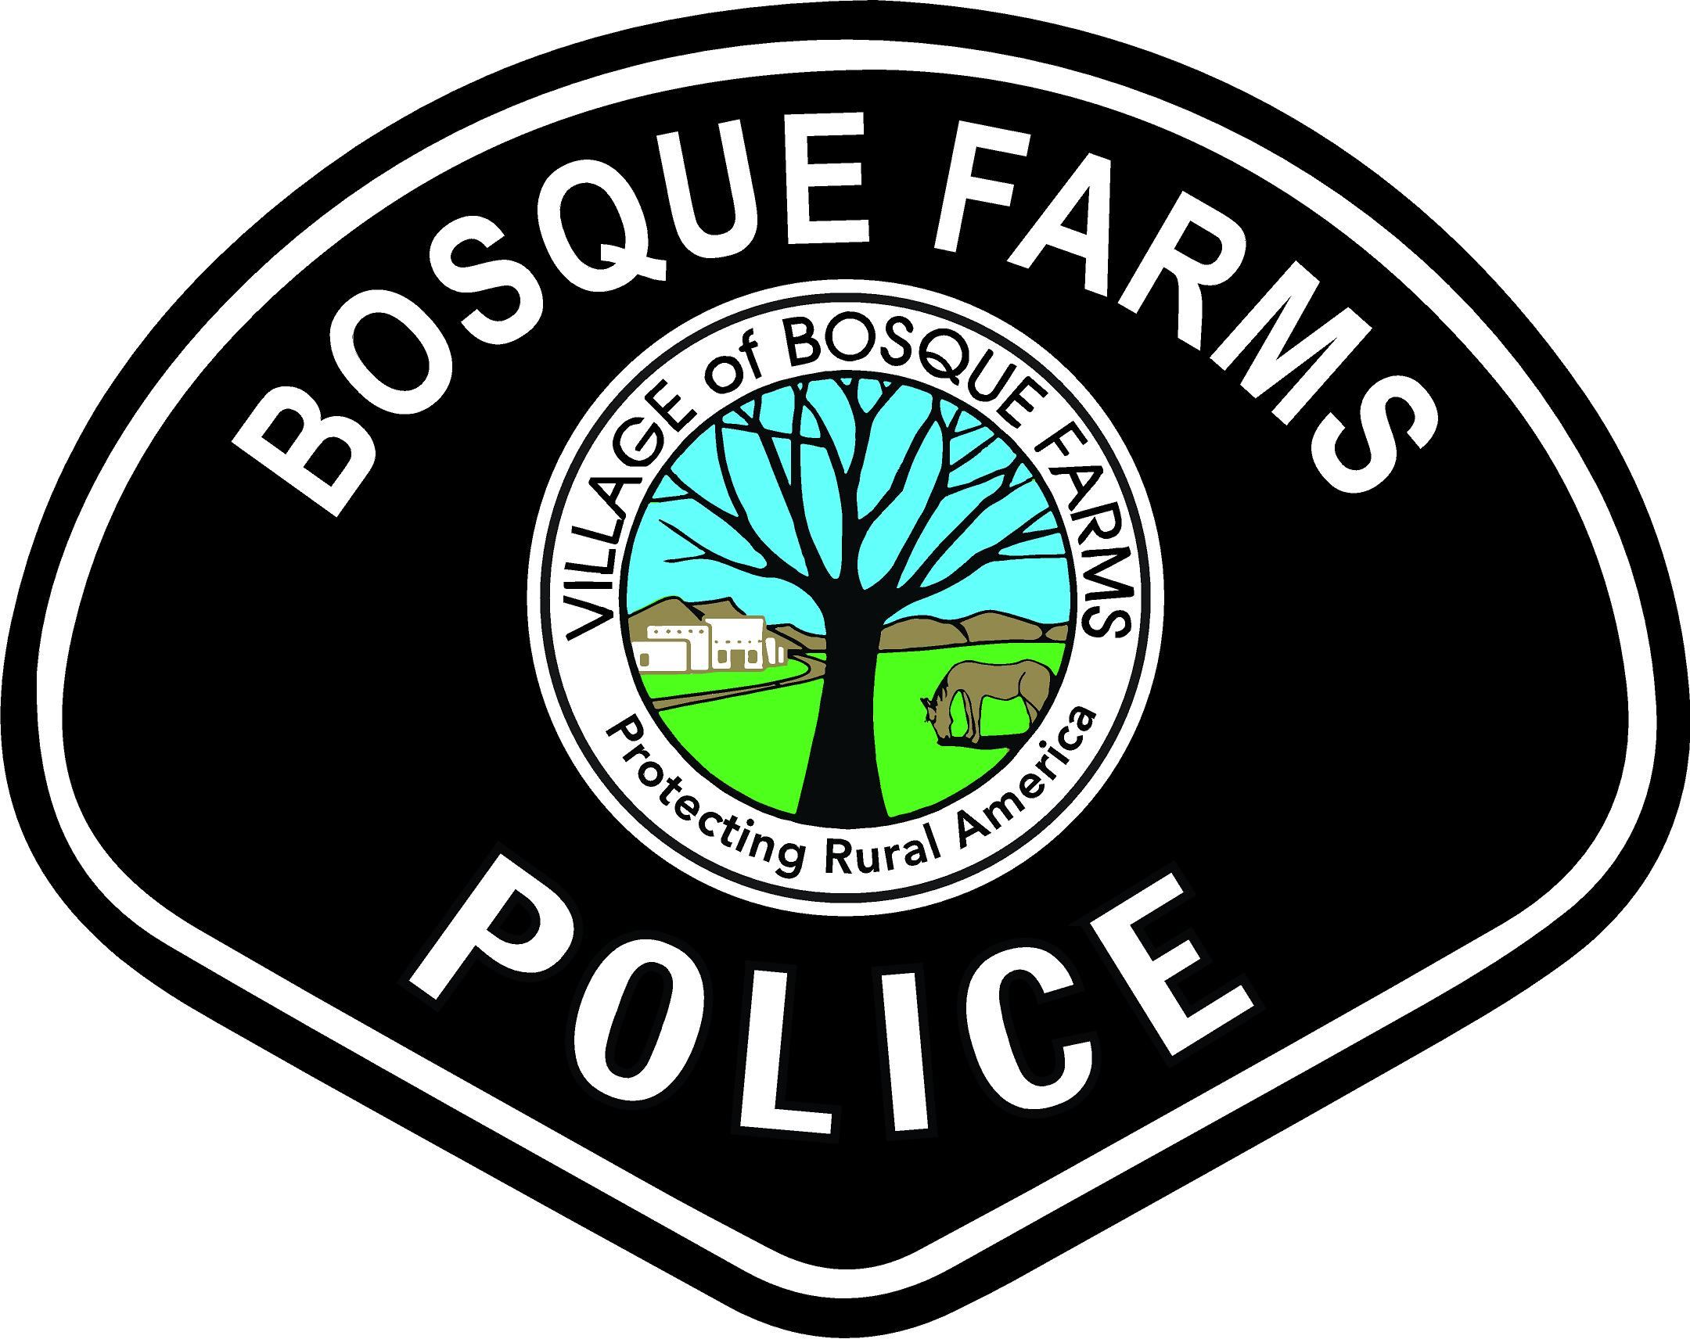

MONTHLY SPECIALTY STATISTICS BREAKDOWN
CRISIS NEGOTIATOR
Mental Health Calls for Service: 6 Pending ACT Referrals: 4
Mental Health Evaluations for Treatment: 8 Total Active ACT Clients: 6
Mental Health Transports: 2 CIT Follow-Ups: 8
New ACT Referrals: 0 CIT/NIT Negotiations: 1

DETECTIVE
Total Cases Assigned: 4 Arrest Warrants: 0
Total Cases Closed: 3 Search Warrants: 0
Active Cases: 1 Returned Stolen Property: 0
Total Reports: 0 SCI Reports: 6
Supplemental Reports: 3 Safehouse Interviews: 0
Felony Arrests: 0 Total Citations: 0
Misdemeanor Arrests: 0 DWI Arrests: 0

DRONE OPERATOR
Drone Launches: 0 Drone Call-Outs: 0
Drone Captures: 0 Drone Reports: 0
Drone Recoveries: 0 Drone Warrants: 0

-Drone Purchase was approved and submitted.
-Drone training continues for certifications.
-Drone SOP written and awaiting Chief approval.
-Drone inventory and compliancy inspections will be completed prior to pre-flight inspections and maiden flight.
-Drone will be registered with the FAA once it arrives.

