BOSQUE FARMS POLICE DEPARTMENT

OBSERVATION PERIOD:
JUNE 1-30, 2026

PRESENTED BY: INTERIM CHIEF ADAMS
MONTHLY STATISTICS BREAKDOWN
CALLS FOR SERVICE TRAFFIC STOPS CITATIONS
BOSQUE FARMS: 266 BOSQUE FARMS: 46 BOSQUE FARMS: 26
PERALTA: 167 PERALTA: 321 PERALTA: 20
TOTAL: 433 TOTAL: 77 TOTAL: 46

ARRESTS DWI ARRESTS REPORTS
BOSQUE FARMS: 3 BOSQUE FARMS: 0 BOSQUE FARMS: 29
PERALTA: 3 PERALTA: 0 PERALTA: 21
TOTAL: 6 TOTAL: 0 TOTAL: 50

Significant Events:
--Ofc. Thom and Ofc. Aragon attended FTO School
--Ofc. Perez and Ofc. Thom received Radar Certification
--Ofc. Webb- continuing with Leading Police Personnel Training
--Sgt. Gordon continuing with Staff and Command
--Ofc. Aragon attended SWAT School
--Ofc. Carrasco attended Police Supervision: Leading with Emotional Intelligence at all Levels

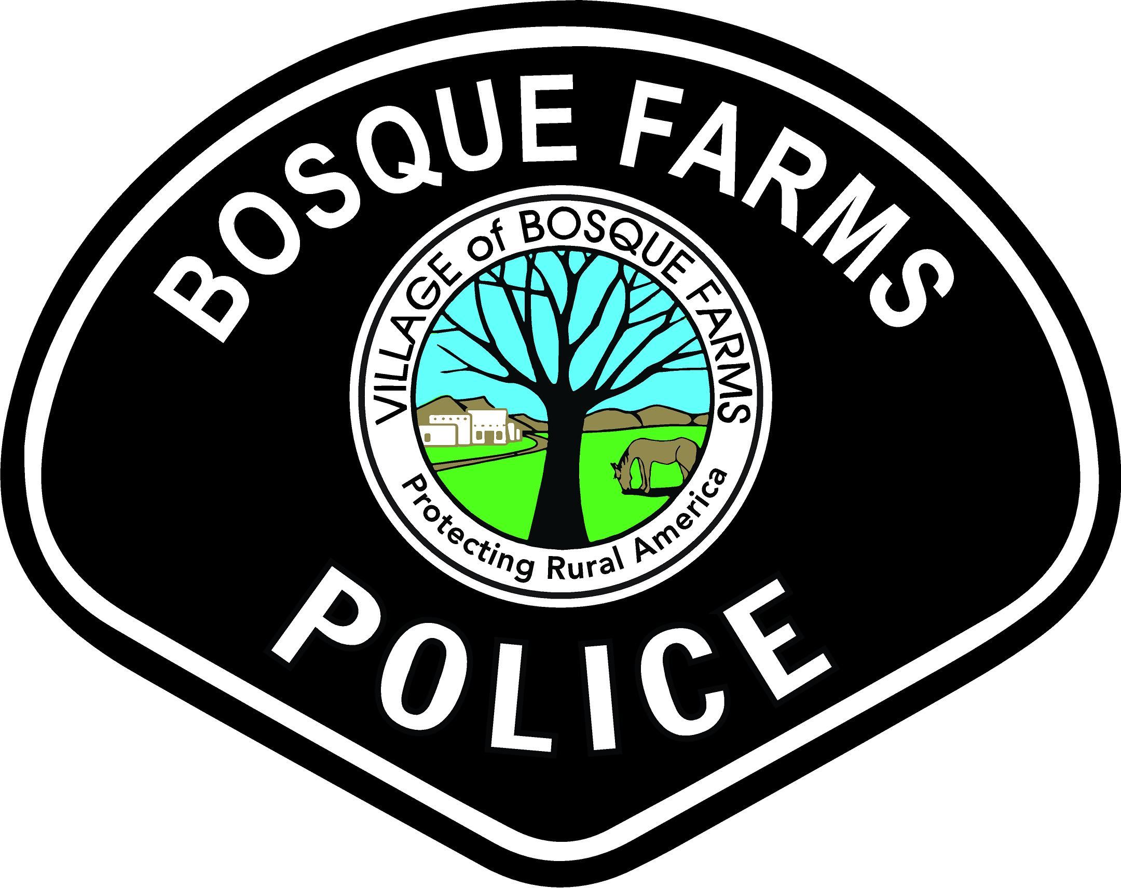

MONTHLY SPECIALTY STATISTICS BREAKDOWN
CRISIS NEGOTIATOR
Mental Health Calls for Service: 3 Pending ACT Referrals: 0
Mental Health Evaluations for Treatment: 3 Total Active ACT Clients: 8
Mental Health Transports: 0 CIT Follow-Ups: 0
New ACT Referrals: 0 CIT/NIT Negotiations: 11

DETECTIVE
Total Cases Assigned: 2 Arrest Warrants: 0
Total Cases Closed: 2 Search Warrants: 1
Active Cases: 0 Returned Stolen Property: 0
Total Reports: 0 SCI Reports: 2
Supplemental Reports: 3 Safehouse Interviews: 0
Felony Arrests: 0 Total Citations: 0
Misdemeanor Arrests: 0 DWI Arrests: 0

DRONE OPERATOR
Drone Launches: 1 Drone Call-Outs: 0
Drone Captures: 0 Drone Reports: 0
Drone Recoveries: 0 Drone Warrants: 0

-Drone launched for aerial photos for a near fatal crash.

